Learning Module – Vital Signs

In this Project, you will be examining data from Vital Signs produced annually by the Baltimore Neighborhood Indicators (BNIA) Alliance at the University of Baltimore. You will then answer the six questions in the Assignment section.

VIDEO: What is BNIA-JFI? https://www.youtube.com/watch?v=jp_CxJ3VbCU&list=PLV7ikfyhfJ8RS8WMPFFBjSybpfu10p3Qi&index=5

Step 1

Go to BNIA webpage by clicking here. Look over the “Who We Are” statement, the projects section, and the “How to Use the Data” section, all on the main page.

READING (Optional): More Background on the Baltimore Vital Signs and Key Indicators https://vital-signs-bniajfi.hub.arcgis.com/app/cd6576dfdfd1438883eee719485f2d34

Step 2

Still on the main page, there is an interactive map in the middle, and where you can select a Community Statistical Area (CSA). Select one of these CSAs, and it will zoom to that CSA. Once you do this, below the map, click on the “View more data about this community” button.

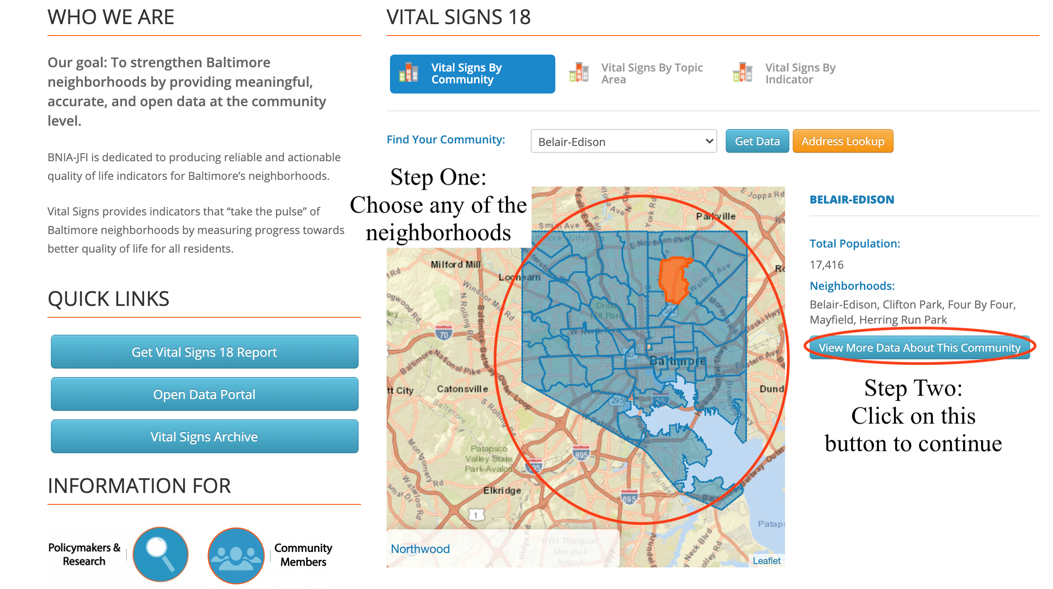

This will bring you to a page for the Community you choose with a list of indicators by Topic Area such as Census Demographics and Sustainability.

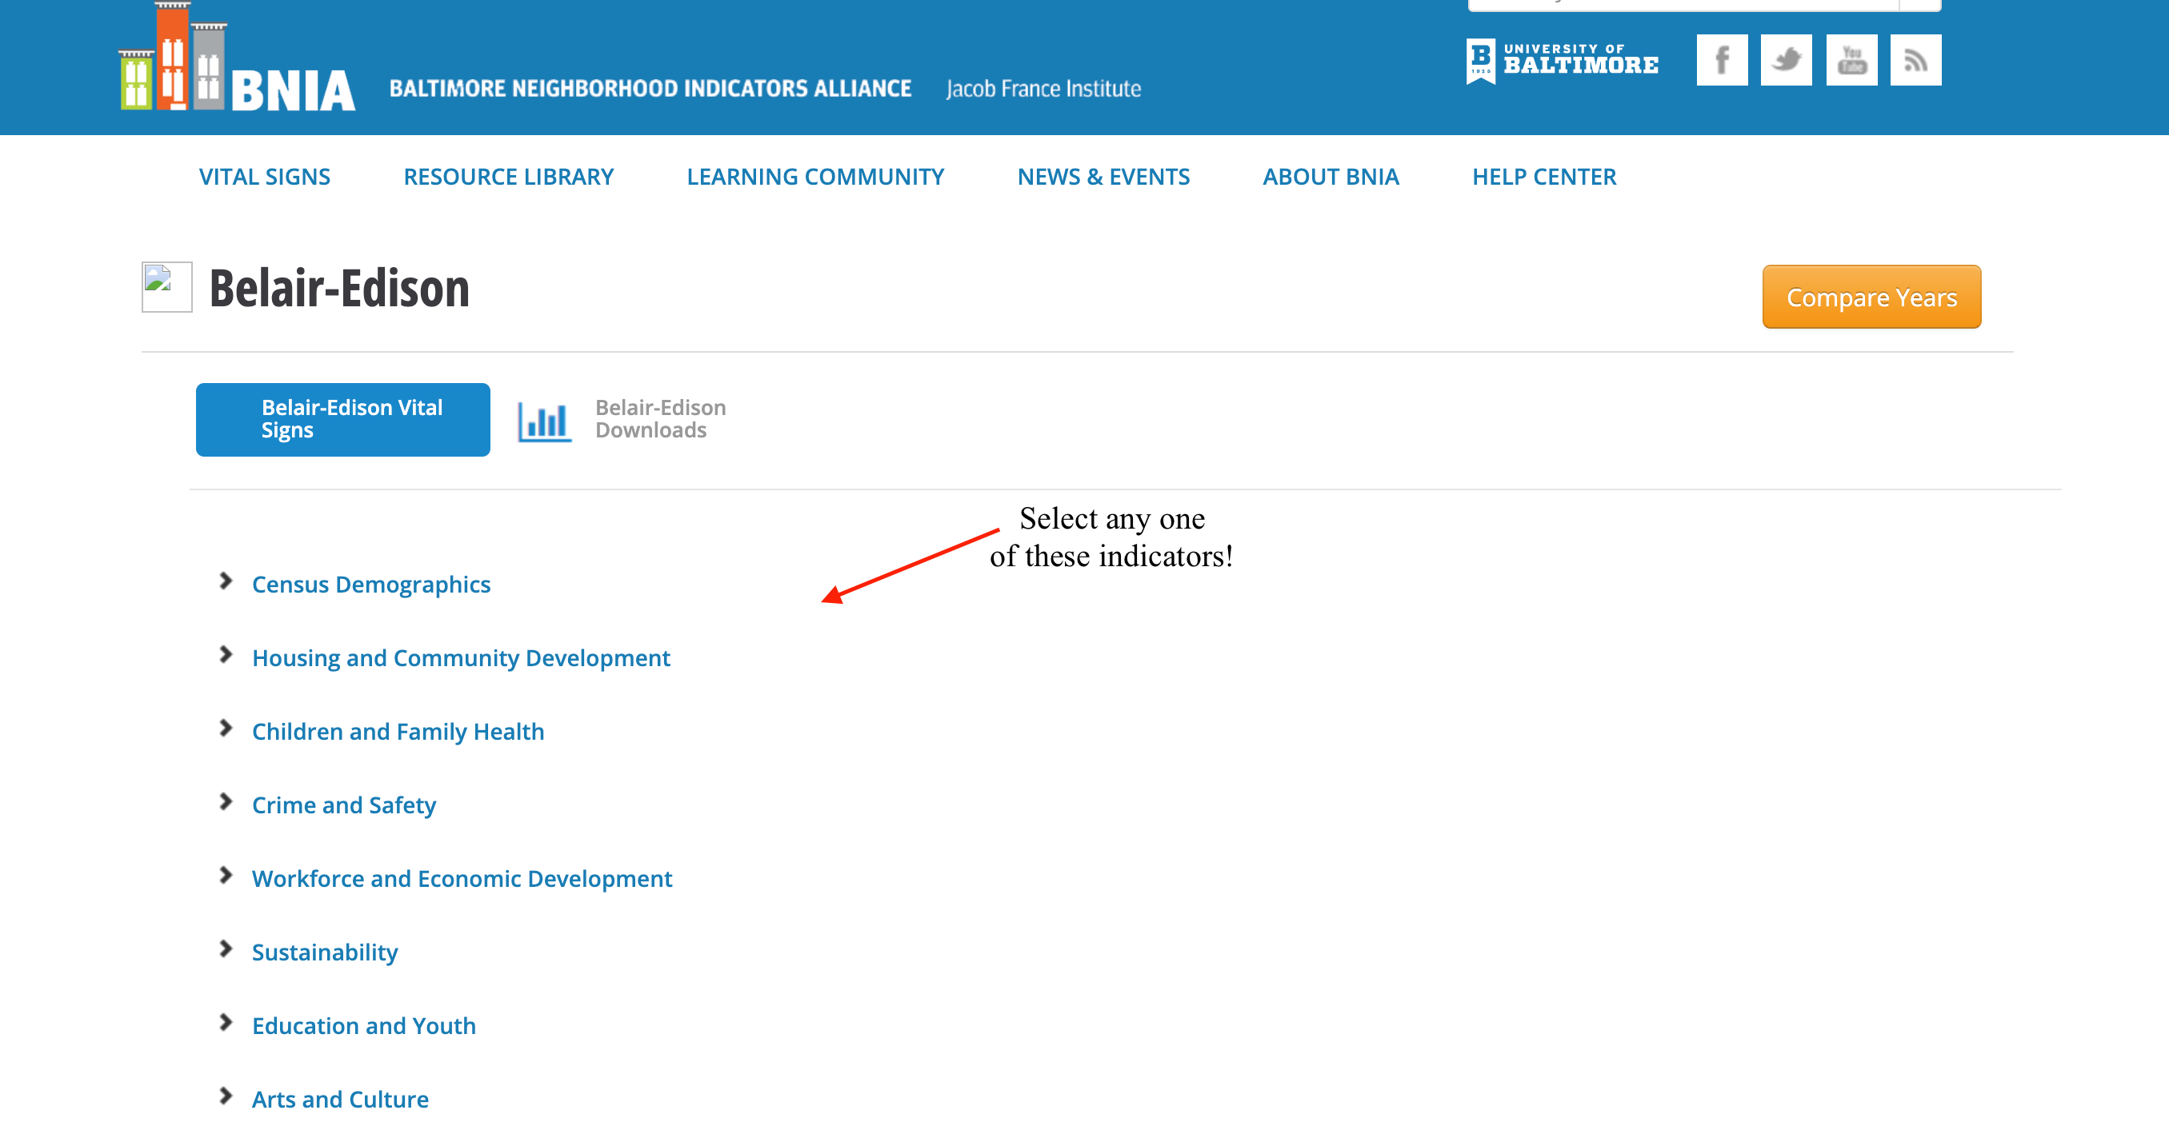

Click on a few of these categories and look through the data for that CSA.
For Example: Under the Topic Area of “Workforce and Economic Development” you can find the indicator “Neighborhood Businesses per 1,000 Residents.”

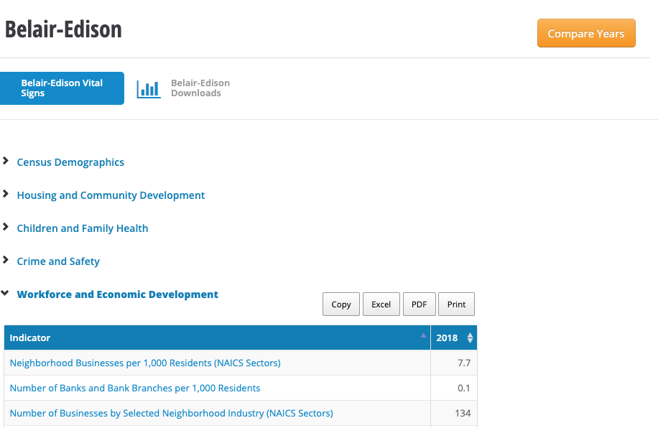

QUESTION: What does this data tell you about that community?

Click on “Compare Years”. You can see how this indicator has changed over time, and how that change compares to Baltimore City as a whole.

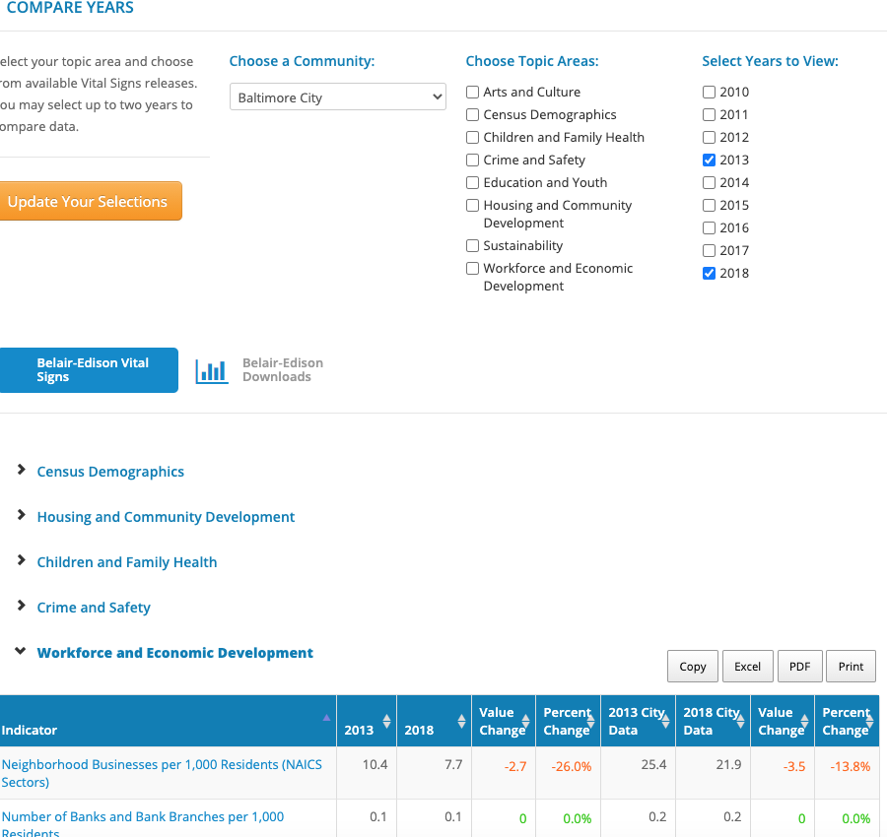

QUESTION: How does this community compare with the City as a whole?

Step 3

Go back to the main page. Click on the tab that says, “Vital Signs by Topic Area”. This will open a menu with the same categories as in the previous step. Click on one these where you will be taken to a page with data about that topic area.

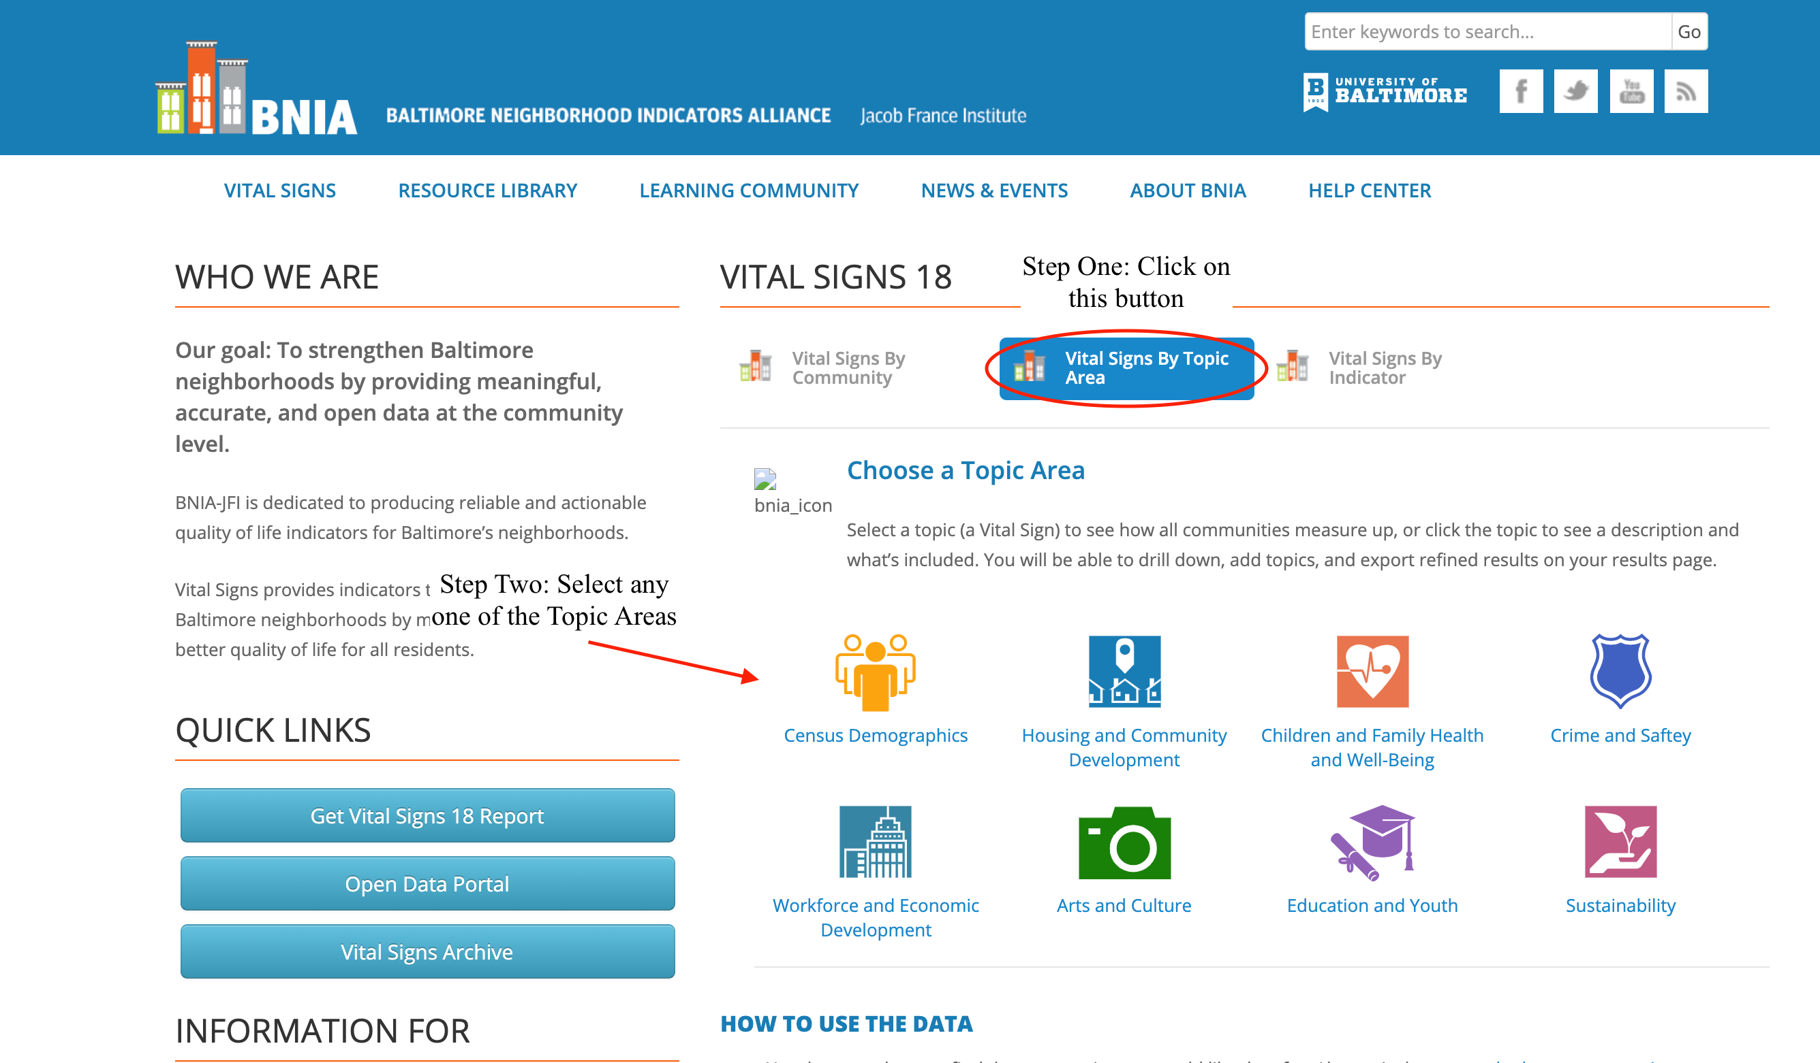

Now go back and choose “Census Demographics.” Think about how it is organized differently than the categories.

Step 4

Now, after choosing one of the categories, look at the list of indicators on the left side of that same page. Scroll down and click on the indicator links “Percent of Family Households Living Below the Poverty Line.”

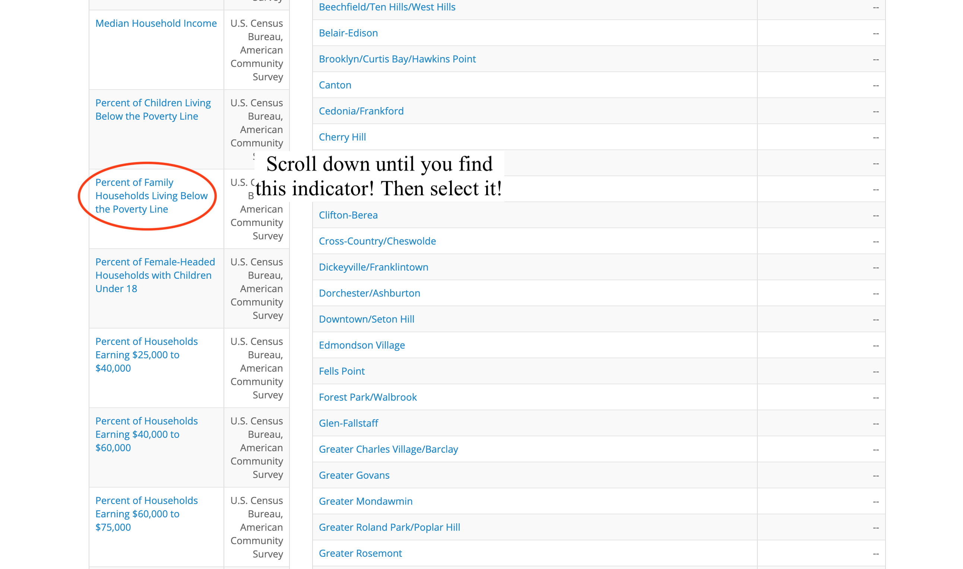
The data will appear to the left of the indicators list. The data is listed in percentages in alphabetical order of CSAs. Look over that data, and then do the same for two other indicators in other topic areas.

Assignment:

Answer the following questions:

- What is the CSA with the highest percentage of Children Living Below the Poverty line in 2018? What is the CSA with the lowest percentage in 2018? What is the average for Baltimore City in 2018?

- What is the CSA with the highest percentage of Female Headed Households with children under 18 in 2018? What is the CSA with the lowest percentage in 2018? What is the average for Baltimore City in 2018? Why might this indicator be important for planning?

- What is the CSA with the highest percentage of Population 16-64 Employed in 2018? What is the CSA with the lowest percentage in 2018? What is the average for Baltimore City in 2018? Why might this indicator be important for planning?

- Go back to the main page and go to the “Vital Signs By Topic Area.” Then click on “Workforce and Economic Development.” Look at the indicator for “Number of Banks and bank Branches per 1,000 Residents.” What do you notice about a large number of CSAs? How do you think this would affect personal financial matters such as savings, loans, etc. in these CSAs?

- Go back to the main page and go to the “Vital Signs By Topic Area.” From the Sustainability topic area, find the Percent of Employed Population with Travel Time to Work of 45 Minutes and Over in the following CSAs: Southwest Baltimore, Greater Roland Park/Poplar Hill, and Inner Harbor/Federal Hill. What does this number signify? Could it be the source of any difficulties or problems?

- Pick a CSA from the map on the main page. List five interesting facts about it from the indicators. Do you see any main problems? Or are there good aspects that the indicators suggest?

Debriefing Questions:

- How can we use these indicators to improve Baltimore CSAs?
- What is an example of a negative attribute indicator? How about a positive indicator?

